Fun fly 2006

All competitions are done on a knockout basis with a pair of identical unpowered deltas dropped at the same time from the same plane. pairings and byes decided randomly:

Each knockout competition scores the following:
1st 5 points
2nd 3 points
3rd 2 points
4th 1 point

In any of the following competitions the plane must be still flyable or only have very minor damage afterwards, a broken plane that can’t be made flyable within 4 minutes is automatically disqualified, if both planes are broken and can’t be fixed within the time limit the person they should meet in the next round gets a bye.

If both planes are repaired within the time limit the one declared flyable first is the one to go through to the next round.

These rules are designed to improve the chances of competitions being completed.

Both planes are dropped by one of the delta pilots who should reach a mutual agreement with the other pilot of when, where and what height to drop all drops should be upwind of the pilots. Certain competitions have guidelines on where the start must be, the dropper pilot should state when the start can take place in this case.

Spot landing
The nearest to the cross wins.

Race
The limbo is set at 90 degrees to the wind
The planes should be dropped upwind of the limbo poles
The first through the limbo into wind wins

If the first plane demolishes the limbo the second wins
If the first plane misses the limbo then: the second must pass through to win
If the second demolishes the limbo the first wins
If the second misses it’s a tie/rematch.
.

Speed limbo
You must pass through the limbo and the furthest to land from the limbo poles wins.

If the first plane demolishes the limbo the second wins
If the first plane misses the limbo then: the second must pass through and land to win
If the second demolishes the limbo the first wins
If the second misses it’s a tie/rematch.

Limbo and spot landing
The limbo is set out at 90 degrees to the wind.
The cross is set 50’ from one pole in line with the limbo poles
Each plane must pass through the limbo and the nearest to the cross wins.

If the first plane demolishes the limbo the second wins
If the first plane misses the limbo then: the second must pass through and land to win
If the second demolishes the limbo the first wins
If the second misses it’s a tie/rematch.
Longest glide
The last to land wins

Loops
A good height is needed for this drop from as high as both delta pilots are comfortable with.

A helper is required for each plane to count the loops
The plane which completes the most complete loops before landing wins.

If there is a tie hold a rematch.

Spot landing race with time difference

The first person to land gets a foot taken off there distance from the cross for every second extra that the second plane is flying.

Nearest to the cross after adjustments wins

Chase

2 round are held in this, one person has the target plane and one has the chase plane.
The target plane must land within a designated area thus:
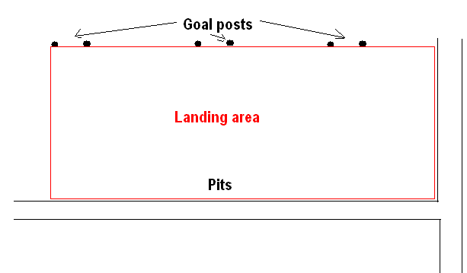
If the target plane lands outside the designated area first the chase plane gets another go but the target plane remains on the ground as a stationary target.

As the chase plane you must land as close to the target plane as you can.

Obviously it is possible the chase plane has to land first. In this case the target plane must land as far from the chase plane as possible but not outside the landing area.
If it is outside the landing area the distance is measured to the edge of the landing area in the direction of the target plane and halved.

The landing area only applies to the target plane.

After a score has been arrived at you swap roles.

The winner is the lowest distance.

