Fun Fly 2004
Deadstick Bombing

The Plane will be equipped with a bomb dropper capable of dropping 4 practice golf balls one at a time.

The course will be set as follows
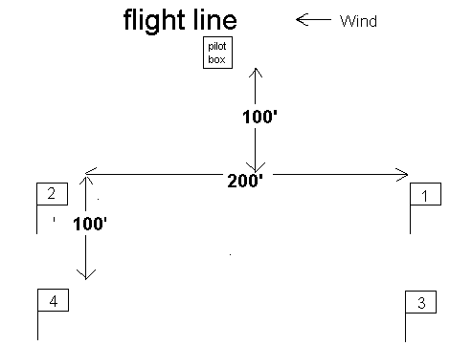
The pilot may climb to any height and then stop the engine all the bombs which are numbered 1 to 4 and dropped in that order must be dropped as near to the relevant numbered target as possible before the plane lands.

Your score is the combined distance each ball is away from its target flag.

2 rounds are flown.

Any ball landing further from the target than 500’ scores 500’

Any ball still in the bomb dropper or dropped after the plane has landed scores 1000’

In case of a dropper malfunction the entire drop is void and must be flown again.

Specific area Touch & Goes

A area 100’ long and 40’ wide will be set out facing into wind the pilot will then have 2 minutes to do as many touch and goes within this area as possible the touch down must be within the area.

Each touch and go will be in the same direction into wind and the plane must point the opposite direction at some point between each touch and go.

Balloon Bursting

Three balloons are set on sticks and placed anywhere the pilot wishes except no balloon may be within 20’ of another the pilot then places the corex cross which acts as the starting and finishing point wherever they wish.

Timing starts when the plane takes off with the pilot at the cross and stops when all three balloons have been burst, the plane is landed and the pilot is back on the cross. If the plane engine stops for whatever reason the timing is stopped as the plane lands and is restarted with the pilot back on the cross and when the plane takes off.

Double Limbo

2 sets of limbo poles are set up 50’ apart the second being narrower than the first 60’ and 40’ spacing.

The Limbo will be in rounds both limbo’s start at the highest position the second limbo coming down by 1’ / round when the second gets to 2’ the first will come down by 1’ / round

If both are down to 2’ both limbos are raised to the starting positions and the subsequent rounds are as before only the plane must be inverted.

3 attempts are allowed at each round, one successful pass allows you through to the next round.

Streamer Cutting

A Crepe paper streamer is towed from a plane doing standard circuits.

You have 3 minutes to try to cut the streamer as many times as possible taking a small amount at a time off the end is the best way to do this.

Parachute Drop

A parachute will be dropped from your plane or another plane directed by you. If you use the second option your plane must start higher than the drop plane.

Once the parachute is dropped you must land and be stationery on the ground before the parachute lands your plane then forms the target for the dropped parachute.

If the parachute malfunctions you may have another go.

The point scored depend on how close the parachute land to your plane, 1 bonus point is scored for landing and being stationary before the parachute lands.

Climb and glide with spot landing

3 rounds

Take off and cut engine after 17 seconds the score is:
Glide time (seconds) – distance from target (yards)

Aerobatics with Touch & Goes

A timed aerobatic schedule:

Take off
Roll loop roll
Touch and go
3 rolls
Touch and go
3 loops
Touch and go
Outside loop
land

Timing is from wheels off on take off to wheels on landing.

The pilot may memorise the schedule or have a caller the first option is recommended and should give a quicker time.

Attempts at this are unlimited throughout the year your personnel best being your eventual time.

General notes

The competitions above may be practised as much as the pilot likes before doing them for the competition most can be practised with minimum equipment I will supply things like the limbo poles for practice if requested. But when it comes to actually doing the comps to save time practice goes won’t be allowed.

In the case of equipment malfunctions another go is allowed otherwise your scores stand good or bad.

All competitions must be completed by the end of 2004.

Please read the rules and familiarise yourself with the competition you intend to do this will also save time.

Pilot :
Event |  | Flag 1 | Flag 2 | Flag 3 | Flag 4 | Total | Score
Deadstick bombing | Round 1
 | Round 2
 |  | Time
Parachute drop
Aerobatics with touch and goes
Balloon bursting
 |  | Points
Specific area touch & goes
Streamer cutting
 |  | Round 1 | Round 2 | Round 3
Climb & glide with spot landing
Limbo

Limbo | Limbo 1 | Limbo 2 | Attempt 1 |  | Attempt 2 |  | Attempt 3
 |  |  | Norm | Inv | Norm | Inv | Norm | Inv
Round 1 | 6 feet | 6 feet
 | 5 feet | 6 feet
 | 4 feet | 6 feet
 | 3 feet | 6 feet
 | 2 feet | 6 feet
 | 2 feet | 5 feet
 | 2 feet | 4 feet
 | 2 feet | 3 feet
 | 2 feet | 2 feet
Start again as above inverted

Points | 1st | 2nd | 3rd | 4th | 5th
Bombing | 8 | 5 | 3 | 1
Balloon Bursting | 6 | 3 | 1
Touch and Goes | 1 point / Touch and Go
Double Limbo | 1 point / round (2 points inverted)
Streamer Cutting | 2 points / cut
Parachute Drop | <20’ | <50’ | <80’ | <100’ | land
Parachute Drop | 10 | 7 | 5 | 2 | 1
Climb and Glide with Spot Landing | 4 | 3 | 2 | 1
Aerobatics with Touch and Goes | 12 | 8 | 6 | 4 | 2

